27U ENCLOSURE 19" CABINET 800X1000 FLOOR STANDING SERVER RACK - VALUCAB
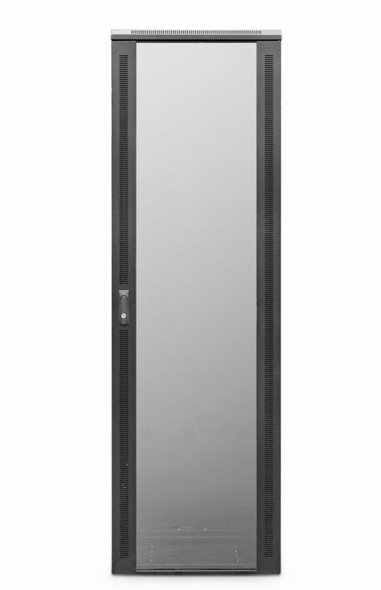

DESCRIPTION
Redefining Cost Effective Data Centre Enclosure Solutions
Wanting a cost-effective, no bundled accessory universal server enclosures for your business?
The new range of LMS Data ValuCab 1000mm deep universal enclosures are
probably just what you are looking for. No bundled accessories such as fan trays
or shelving, just a standard, UK assembled 19-inch enclosure available in a range of
popular sizes.
With an extended enclosure depth means you can deploy almost all rack mount servers from the likes of HP, IBM, Dell and Fujitsu with minimal fuss*. Ideal
for the extra deep form-factor also of managed switches, SAN and of course
rack-mount power solutions, the LMS Data ValuCab is ideal for both private and
public sector deployments.
LMS Data does not skimp on the accessories you will always need, these
included ball-raced castors and fitted jacking feet to help deploy the ValuCab in
its ideal position, securely.

SPECIFICATIONS
- ETSI 19” front/rear profiles, adjustable
- Vertical Cable Management (800mm wide only)
- Lockable mesh front door, reversible if required
- Removable side panels, rear lockable door
- Ideal for Dell(tm), IBM(tm), Fujistsu(tm) servers
- Supplied with Castors and Jacking Feet
- UK Assembled and quality assured

TECHNICAL INFO
SKU/MPN: CAB-FE-27U-8100NA
EAN: 8400800034700
Weight: 105.0 Kg
Dimensions: 800x1000x1370 (mm)

FILES
Datasheet - CAB-FE-27U-8100NA

